4 Quick Fixes to Make Your Website a Lean, Mean, Conversion Machine!

With Marisa Murgatroyd

It’s a myth that lead pages are the only way to convert better. Every page on your website can be set up to convert traffic into visitors and customers.
Every page can convert because people could land on almost any page
TOP OF HOME PAGE
Optimize the first 600 pixels, the “above the fold real estate,” what they can see without scrolling down.
Create a call-to-action (CTA) banner that asks them to do something. (Discover Call (SS) or opt-in)
You want people to know what to do next. If they can’t figure it out immediately, they don’t have to search for it. This alone will double your home page conversion.
What is best CTA for your business?
- Call me CTA. Easiest place to start and fastest way to grow business. Best for 1:1 advice and services (coaching)
- List build CTA: best way to scale your business and leverage your time. Requires more expertise, systems and support. If you make your money selling digital or physical products, trainings, group programs, software or ongoing subscriptions. For people who are maxed out with 1:1 clients. IF this is your model, you must not only build but nurture your mailing list quickly
- “Authority” site, the path to massive, global impact. Long-term model that requires significant team support and resources, it’s not the fastest pathn to profit. For authors, speakers, media personality or thought leader who has multiple channels, including books, speaking and high-end sales. This model requires more high-level marketing, to give impression you are everywhere. Your #1 jove is to build your brand, grow your trive, spark massive engagement in as many places as possible.
Biggest reasons people struggle is that:
- their CTA doesn’t match their business
- They’re using right tools but at the wront time/place in their business
- Focus on the rigth CTA fo ryour business to cut your bounce rate and increase your home page conversion.

List-build Template
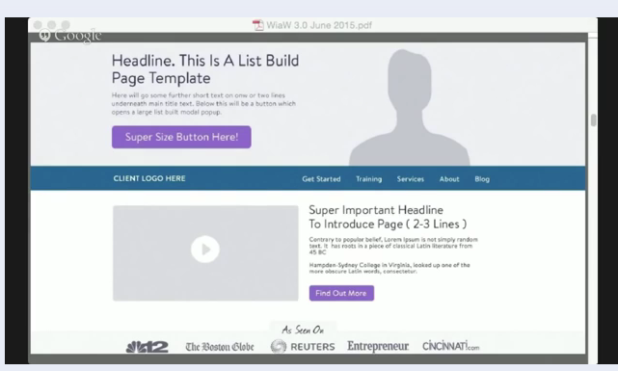
Like a landing page with CTA front/top
They see CTA before the navigation, which is below top of fold.
Use a modal, a fill in pop-up. But many people will leave with pop-ups.
Past year people are using micro-conversions, asking people to do little steps
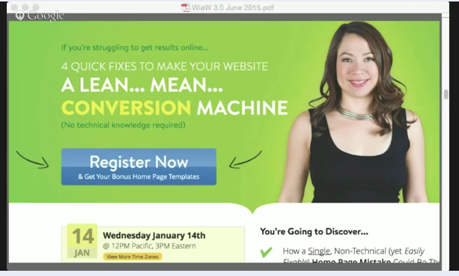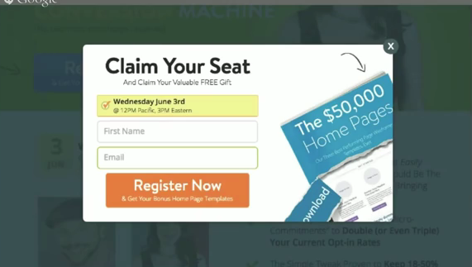
Once they click once then they are more willing to fill in a pop-up
(i.e., click here to register button),

The call-me CTA template
This template has THREE CTAs
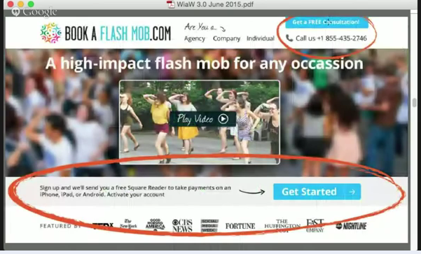

Authority Site template
High-end clients want to see who you’ve worked with, what you’ve done and what you believe. They want to know you are the best. They want to know what the experience of working with you will give them.
Often lead with a big picture of yourself (the expert) and not ask them to do anything in particular.
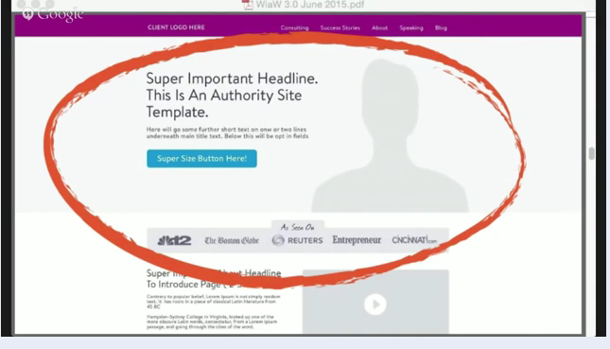
Branding and authority/expert is front/center.
Combine best of both worlds by still having a CTA button, such as an opt-in report.
The focus, though, is your brand and positioning you as an expert/authority.

Website Do’s and Don’ts
- Good Design Will
  - Get you noticed, instrantly attrace your IC and differentiate you from everyboey else out there who does what you do (this losers bounce rates)
  - When done right it focuses people’s attention so they take action (boosts conversions)
- Distration happens when you pull focus away from what you want them to focus on. Distraction is a more natural state than focus. It’s easier to distract people than to get them to focus. Use graphic design in a way to draw attention where you want it.
- Simplicity helps people focus.
- Use color to help draw attention to where you want them to focus. Use same color for all CTA buttons so people are trained to look for that color to take action.
- Too many characters at top distracted from opt-in.
- Do split testing to see what works best.
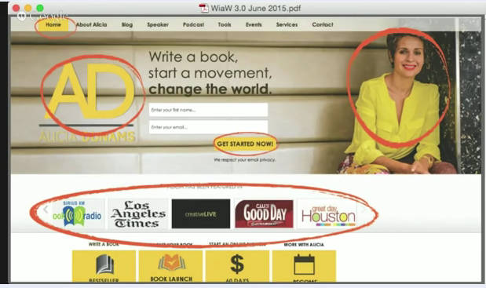
All these yellows pulled eyes in different directions.
The eye sees contract. Here’s Alexis Neely’s site. See arrows?
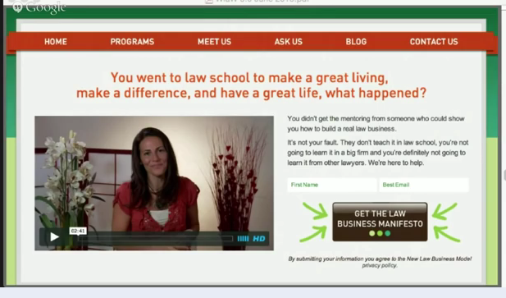
Justin Livingston’s site ($4million). Use thin gray arrows to move eyes down page. Especially good for a long sales page.
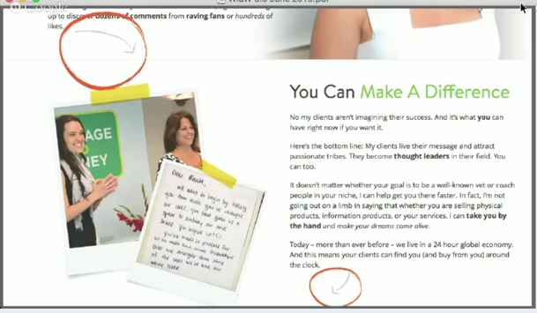
Can also add wedges and different colored sections to draw people down the page.
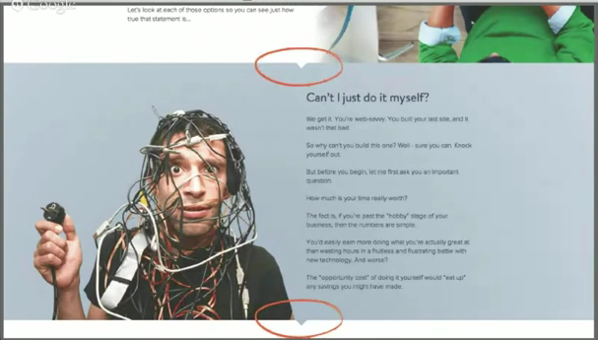
Many designers went to design school, not business school, so they might resist breaking the harmony in the design, but not doing that will reduce conversions.

Mobile friendly sites
Mobile browsing now exceeds desktop browsing. If your site doesn’t look good on mobile, you’ll lose visitors.
Responsive sites create an optimal viewing experience on each device
Their launch got 94% conversions!

Website in a weekend: $997 http://lymurl.com/go/tfn-bb-jun3
Program was closed already! For them to do it for you, it’s $3000 after the $997

